

**Save the Date**

**What MOAR on Addiction Prevention,**

**Treatment, and Recovery**

**With BSAS Director Deirdre Calvert,**

**City of Boston Office of Recovery Services,**

**Jennifer Tracey**

**Recovery Community Organizations,**

**People in Recovery and MOAR!**

**Individuals and Families in Recovery and**

**YOU are invited!**

**2021 Forum with Direction for 2022**

**Organized by MOAR & Friends.**

**With Policymakers, State and City Leaders, Recovery Community Organizations,**

Email – [JulieB@MOAR-Recovery.org](mailto:JulieB@MOAR-Recovery.org)

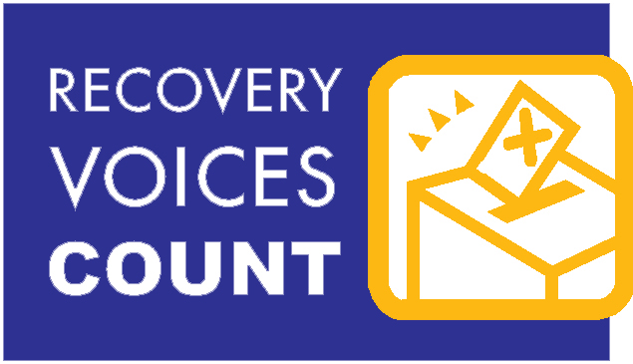

**Thank You to Massachusetts Department of Public Health – Bureau of Substance Addiction Services, City of Boston – Office of Recovery Services,**

**Boston Public Health Commission, Community Coalitions, Individuals & Families for Recovery!**

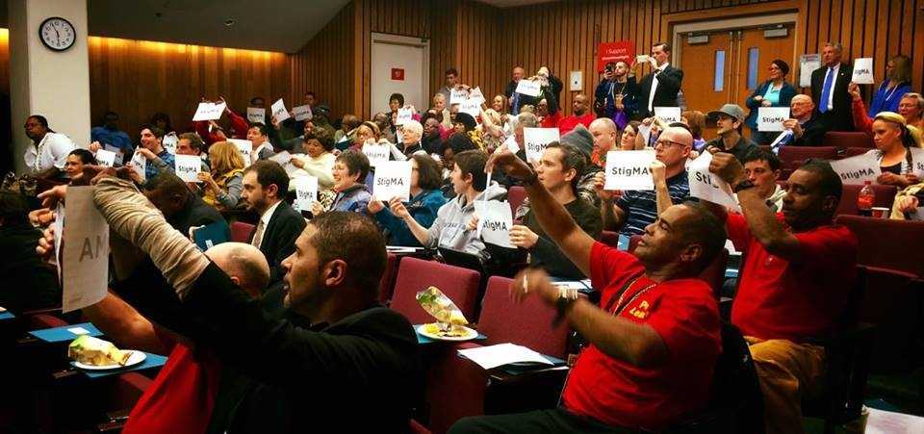

**Visible, Vocal, Valuable Voices For Recovery**

18th Annual

**Public Policy Dialogue**

**On ZOOM**

A ZOOM Registration Invitation

will be sent!!

RSVP to Maryanne@moar-recovery.org

Call 617-423-6627

29 Winter Street • Boston, MA 02108 • 617-423-6627 • www.moar-recovery.org